

SYMBIOSIS INTERNATIONAL (DEEMED UNIVERSITY)
(Established under section 3 of the UGC Act 1956)
Re-accredited by NAAC with “A” Grade

Name of the Student: Sneha Sah PRN: 25070122189
Semester: 3 Year: AY 25-29

ASSIGNMENT No: 6

TITLE: Write a Java program to demonstrate the use of an inner class, an anonymous class.

Problem Statement: Write a Java program to demonstrate the use of an inner class, an anonymous class.

Source code:
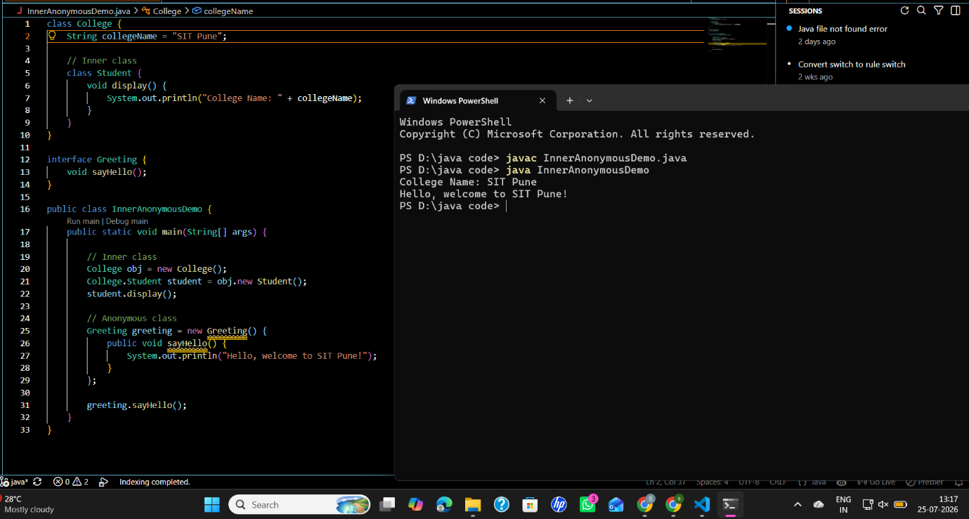

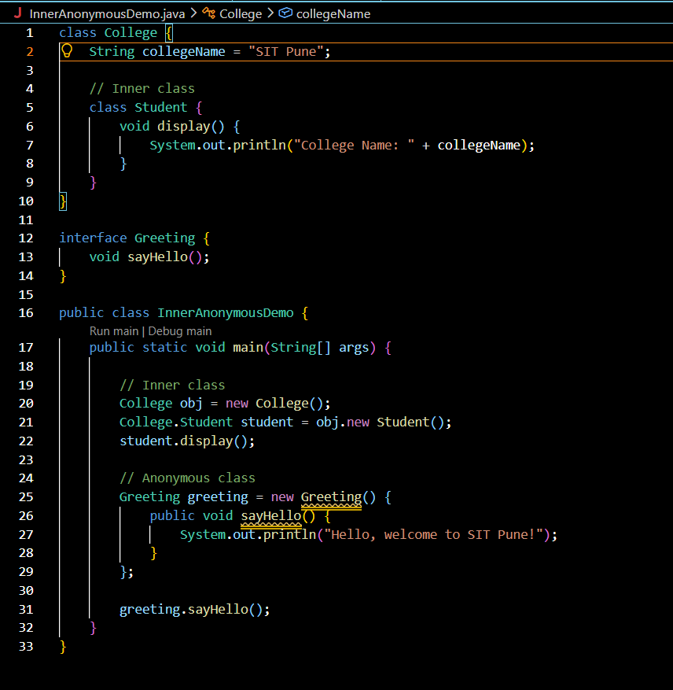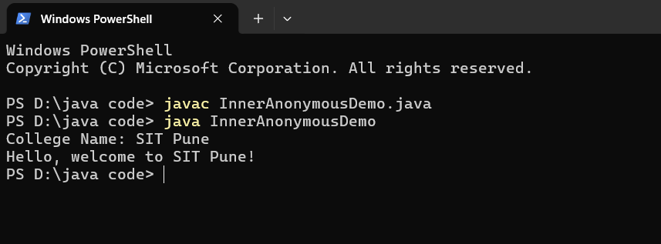

Exercise 1.Create a Vehicle program where an inner class displays vehicle details and anonymous class performs an action.
Source code:
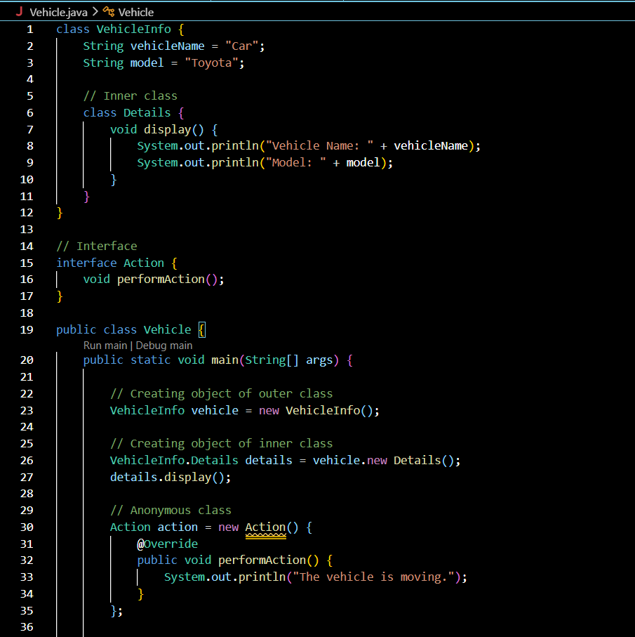
Output:
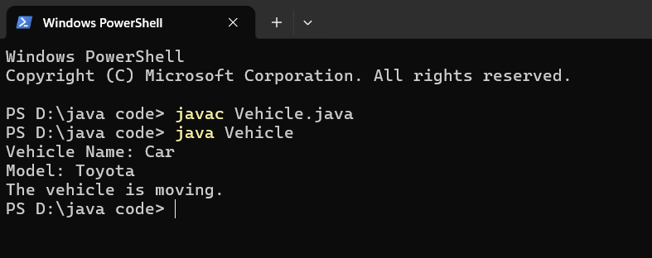
2. Develop a Food Delivery Application where an inner class handles order details and anonymous classes handle delivery status updates.
Source code:
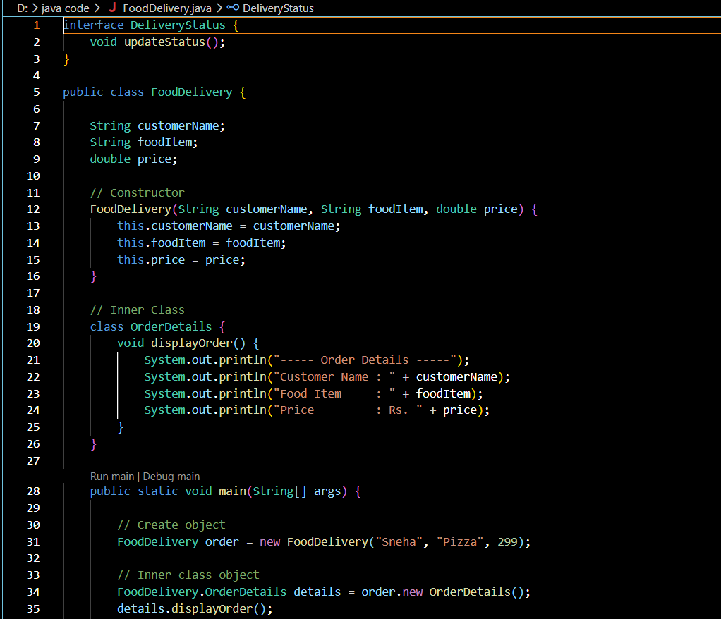
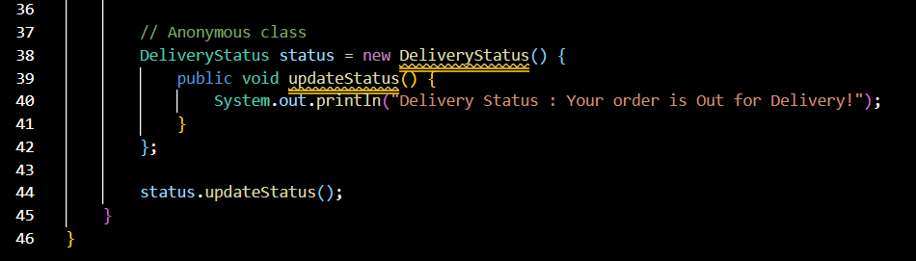
Output:
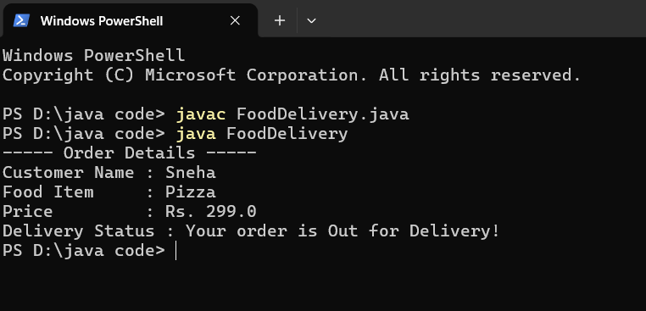
Conclusion
This assignment helped me understand the use of inner classes and anonymous classes in Java. I learned how inner classes improve code organization by grouping related functionality, while anonymous classes make the code shorter and are useful for one-time implementations such as event handling. By developing the Vehicle and Food Delivery applications, I gained practical experience in applying these concepts and improved my understanding of Java object-oriented programming.

